Appendix Q. Entity-Relationship Diagram (ERD) and Table Group Overview

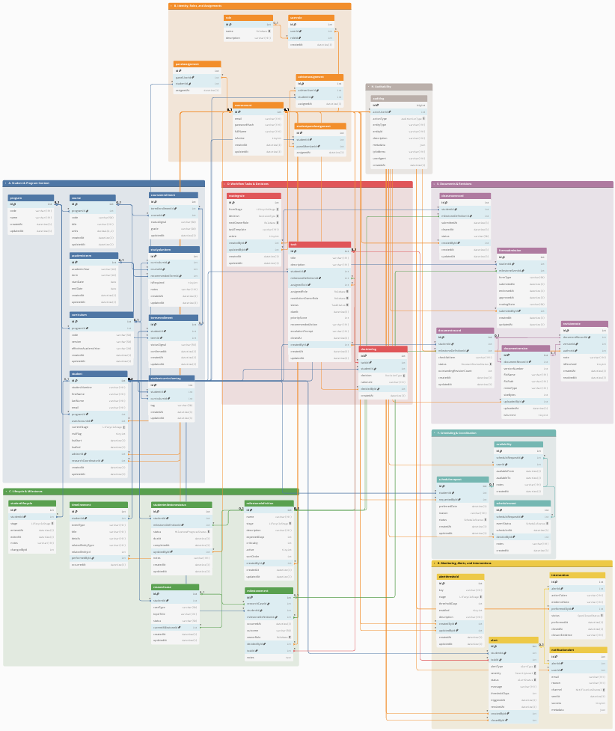

Appendix Q.1. Group A. Student and Program Context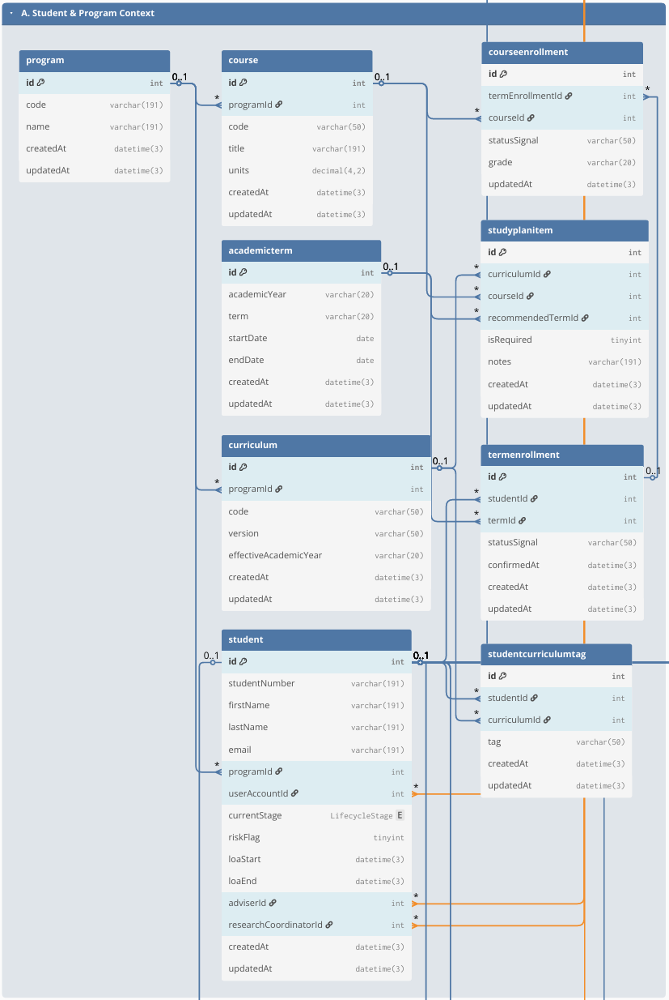

Appendix Q.2. Group B. Identity, Roles, and Assignments

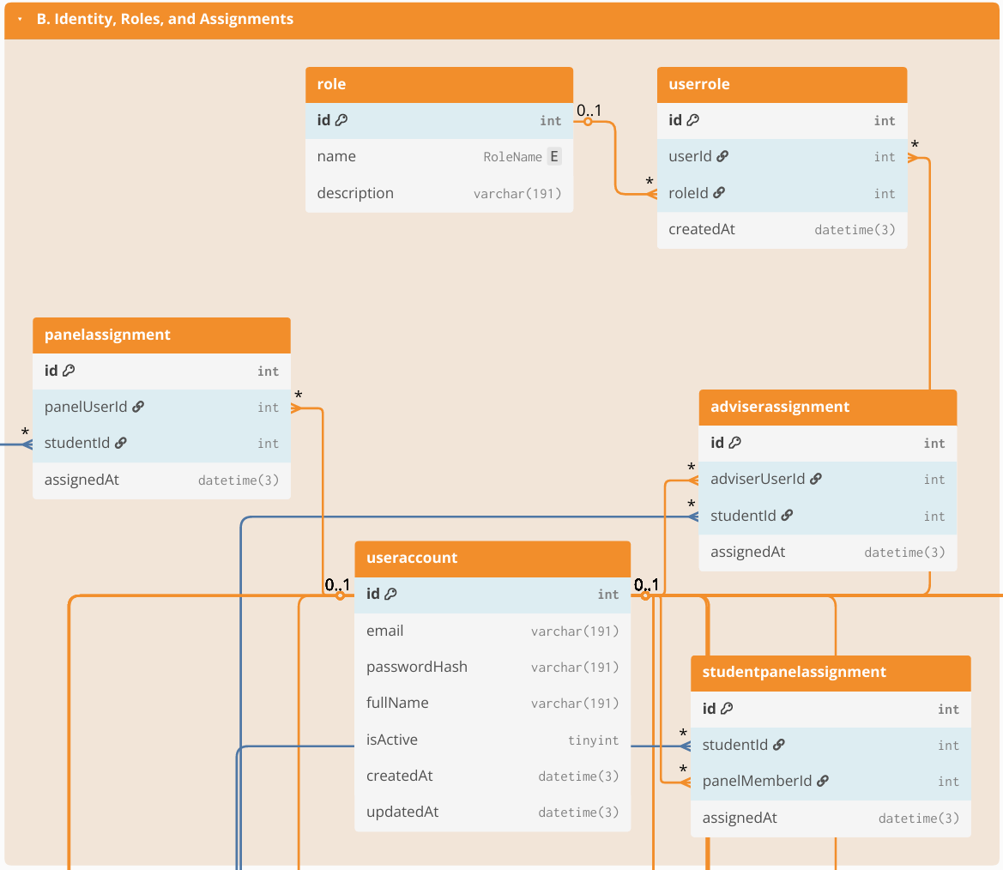

Appendix Q.3. Group C. Lifecycle & Milestones

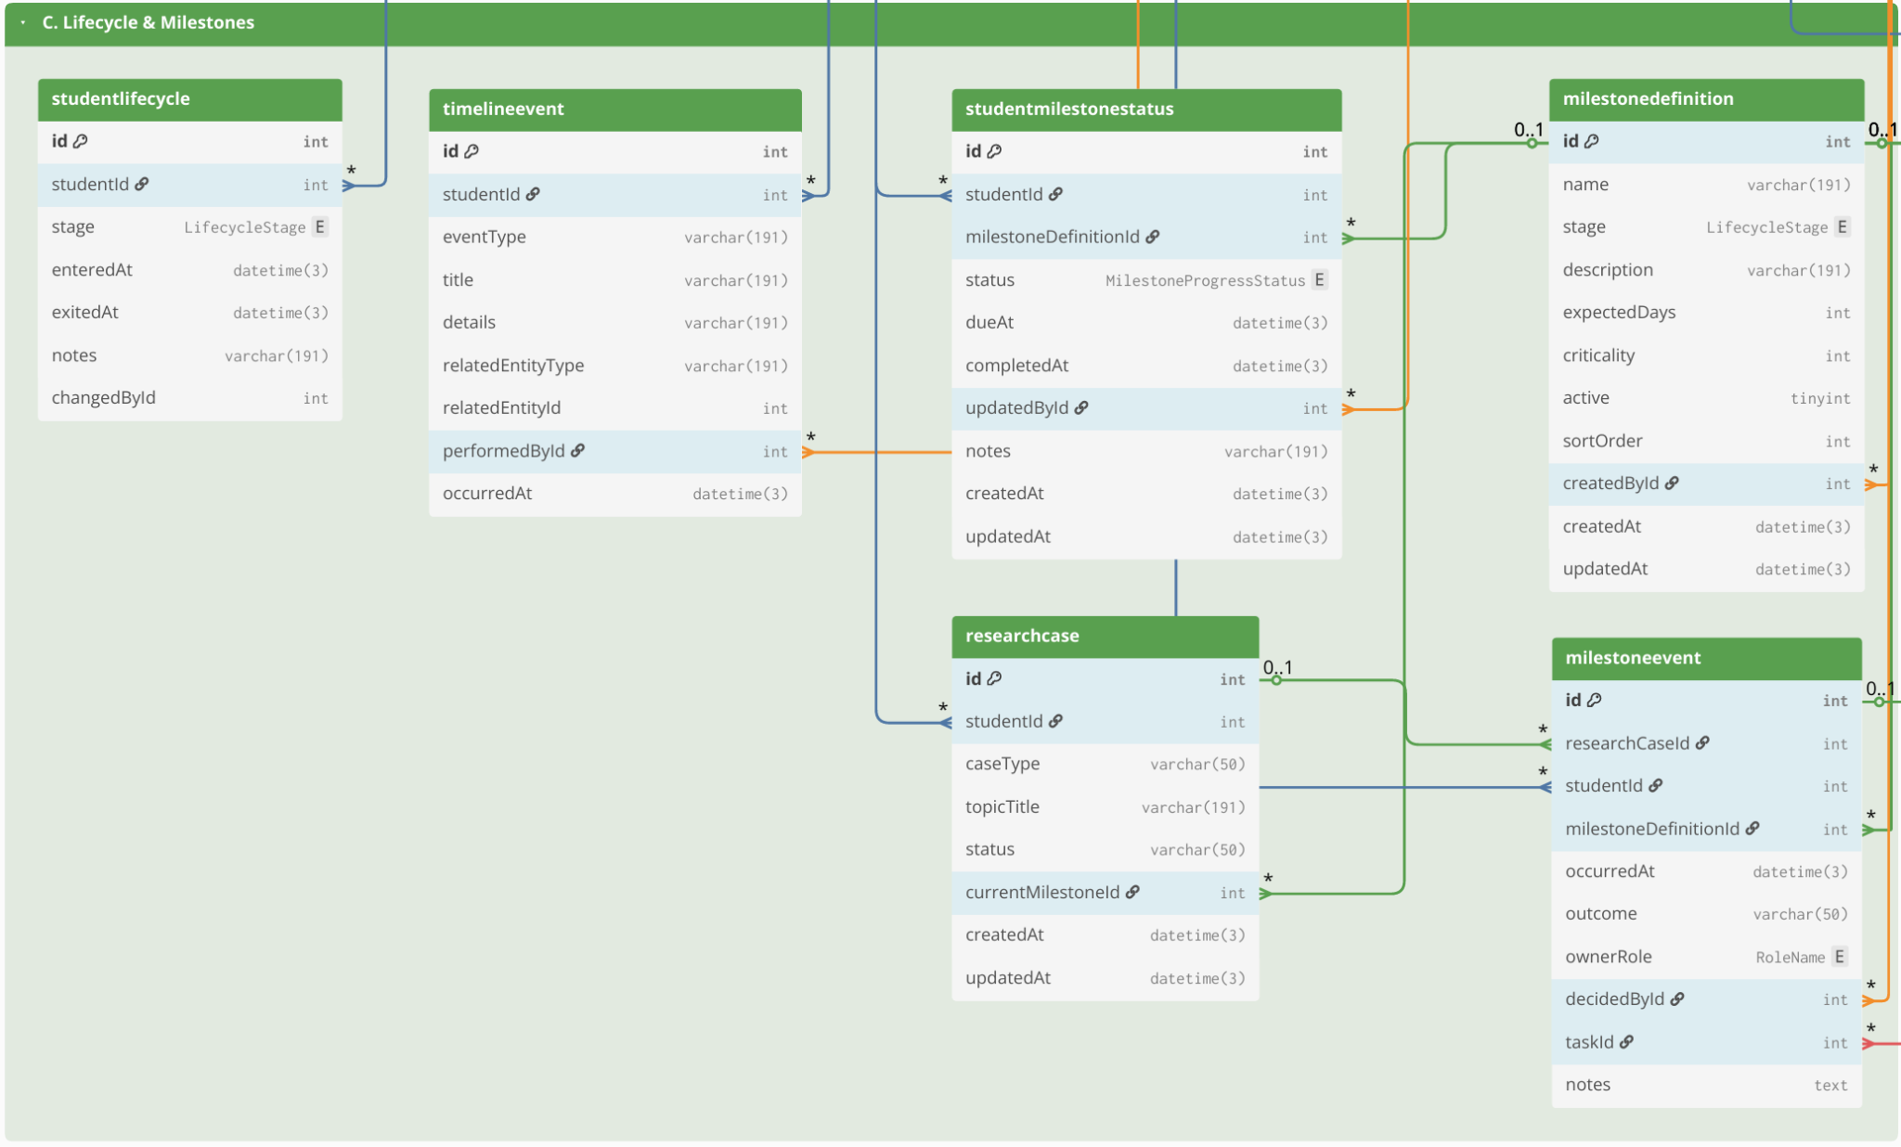

Appendix Q.4. D. Workflow Tasks & Decisions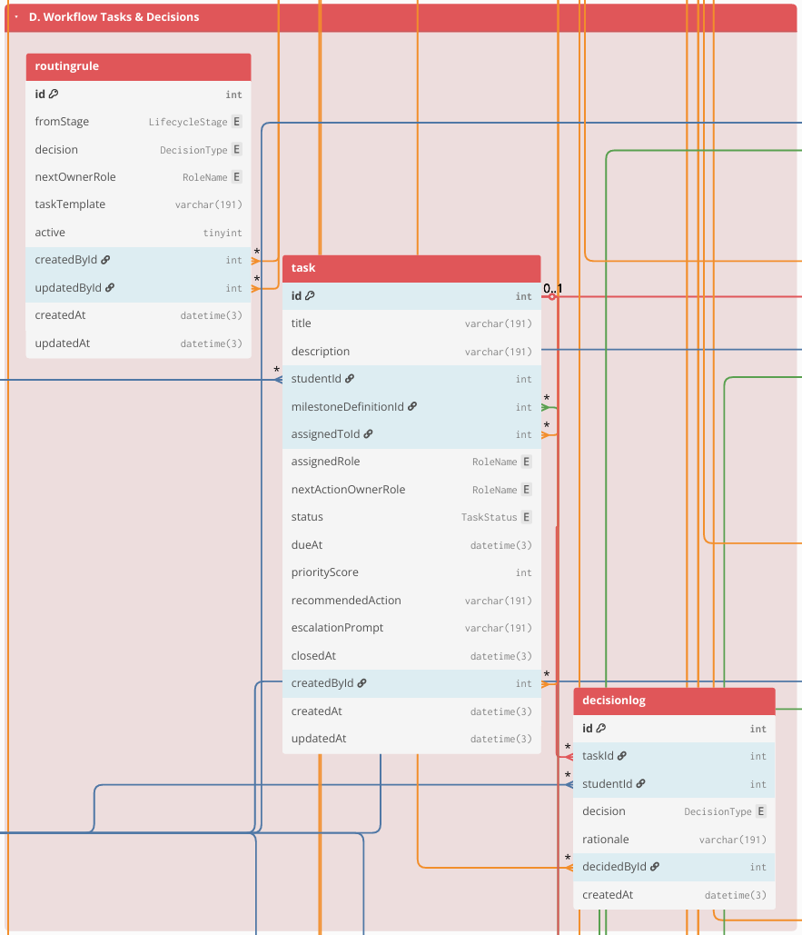

Appendix Q.5. Group E. Documents & Revisions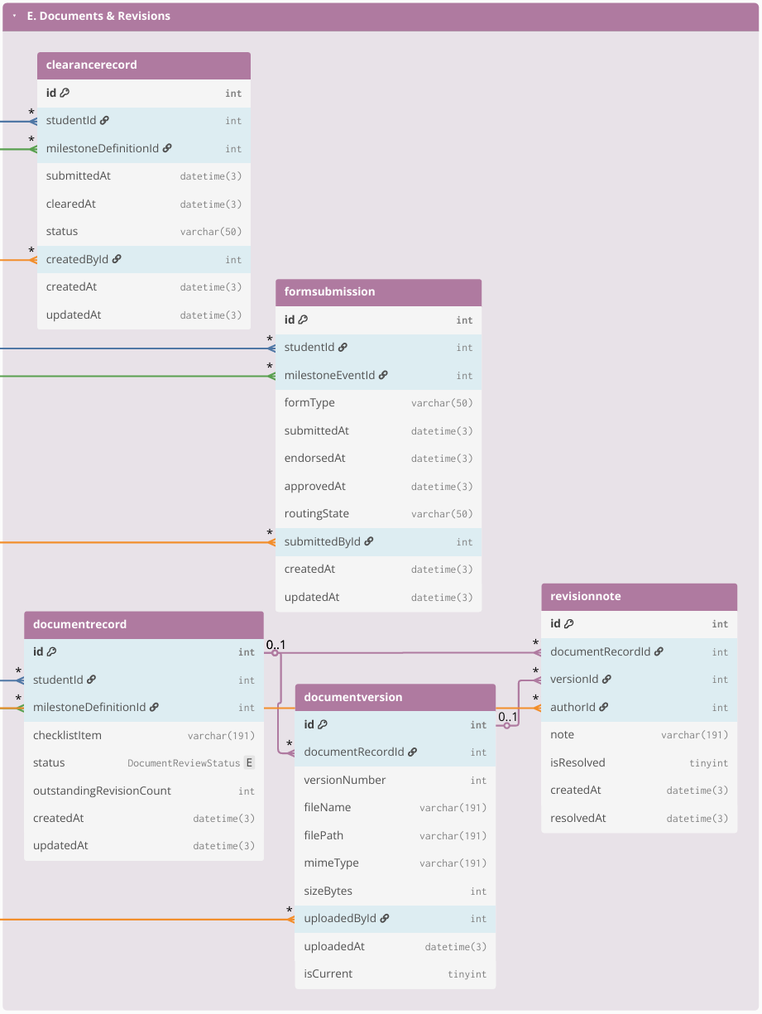

Appendix Q.6. Group F. Scheduling & Coordination

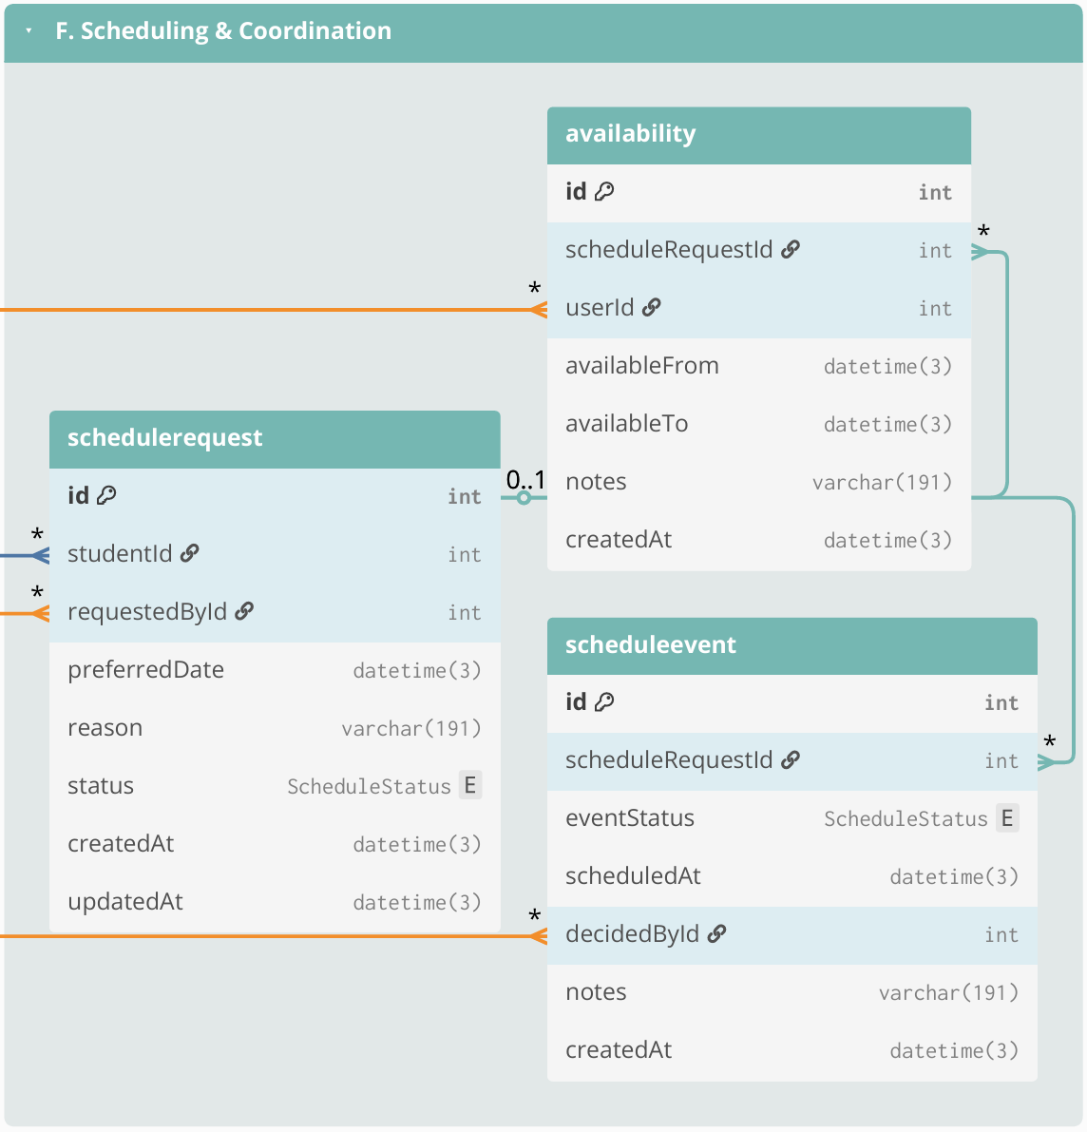

Appendix Q.7. Group G .Monitoring, Alerts, and Interventions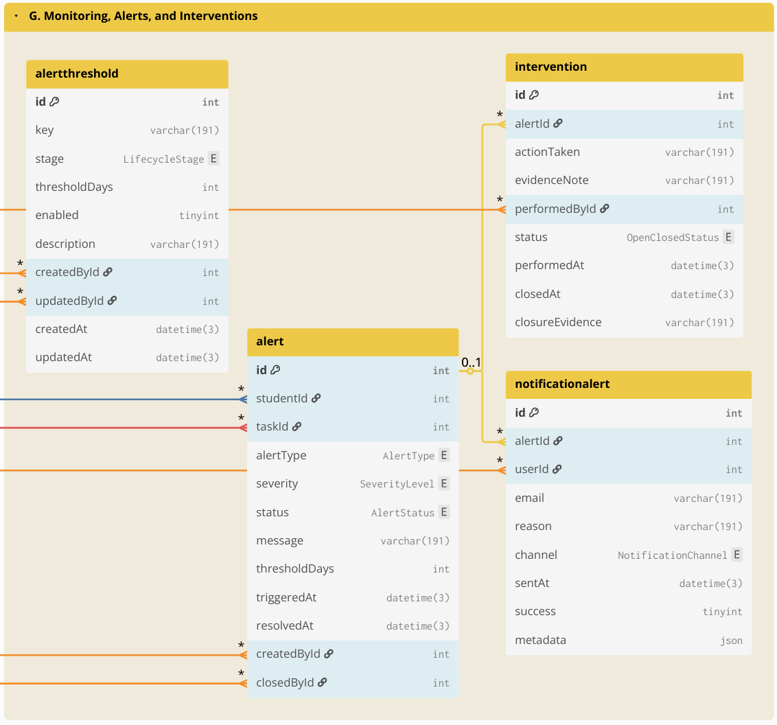

Appendix Q.8. Group H. Auditability